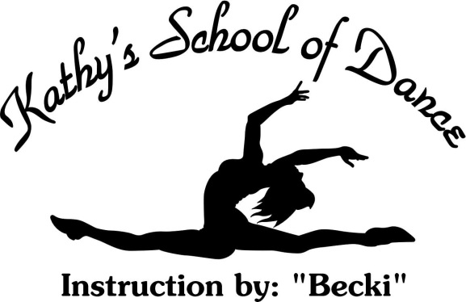

Dear Parents,

Enclosed is the schedule for the 2017-2018 dance season. Dance will begin on Monday September 11. I have highlighted the days and times of the class options for your child. Please understand that this schedule is tentative and will be based on the registrations received. With that in mind, please know that I will do my best to place your child in classes that are convenient for your schedule.

Please contact me if you have any questions. My email address is beckiksd@gmail.com . Classes tend to fill up quickly, so please send your registration as soon as possible to ensure your child’s spot in class.

Dance shoes and tights will be sold at the studio on August 29th between 3:00 and 7:00. To ensure that your child will have the proper shoes for the first class, please purchase your dance shoes at the above day and time. This will allow time to order your child’s shoes in the event that I do not have them in stock. If you have not registered for classes when you come in for shoe fitting, please register at the desk before getting your fit for shoes. Pre-registration is highly recommended to ensure class availability.

Please check the box on the attached schedule next to the classes in which your child would like to enroll. Mail the schedule, registration form, and the registration fee of $15.00 before Aug 18th or $20.00 after Aug 18th to:

Rebecca Zvonek – Love
312 Grandriver Rd
Bancroft, MI 48414

PLEASE BE SURE TO MARK THE DATES AND TIMES OF YOUR CHILD’S CLASSES AND SHOE FITTING DAY ON YOUR CALANDARS.

Enjoy the rest of your summer!!!

